LAB 13 Bayes Classifier
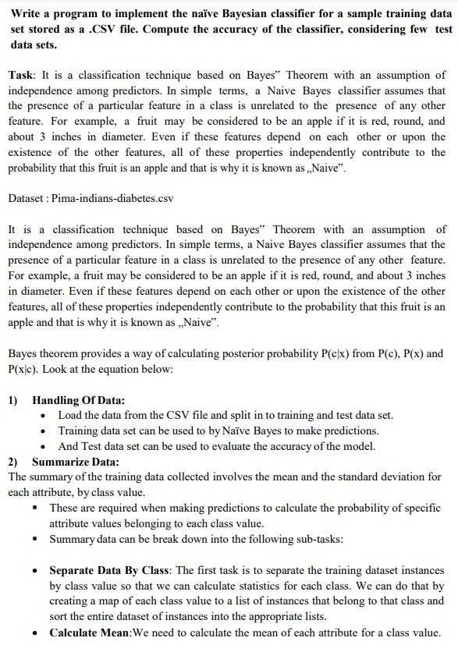

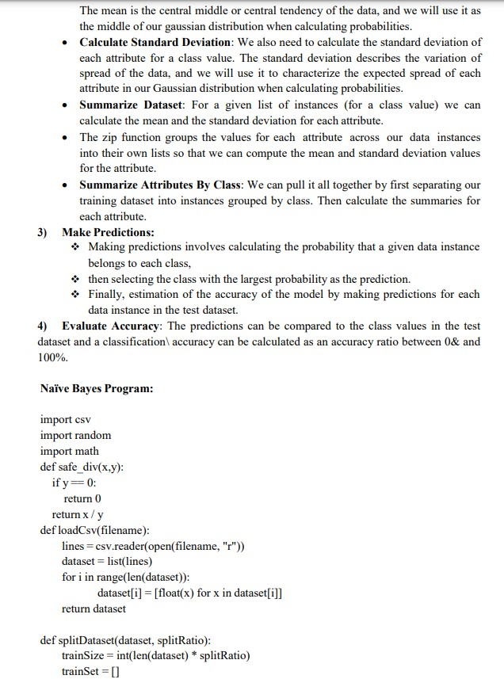

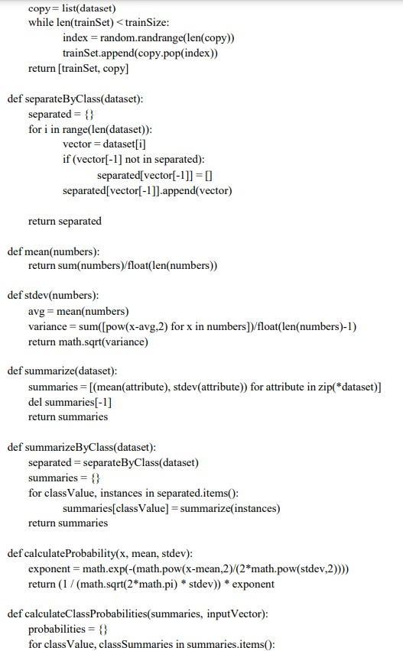

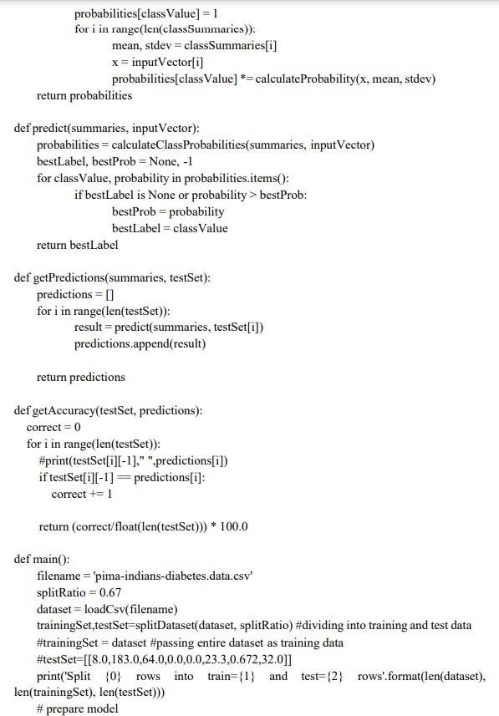

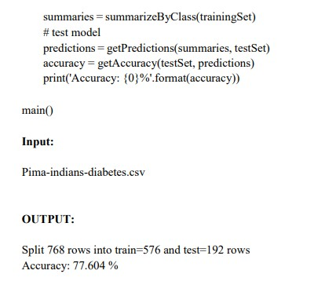

❖ Naive Bayes is a classification algorithm that is based on Bayes' theorem. It assumes that the features are conditionally independent given the class, which means that the presence or absence of a particular feature does not affect the presence or absence of any other feature.

Here's an example to illustrate how the Naive Bayes algorithm works:

Let's say we have a dataset of emails labeled as either "spam" or "not spam" based on their content. We want to build a Naive Bayes classifier to automatically classify new emails as spam or not spam.

Step 1: Prepare the Data
We preprocess the email data by converting them into numerical features. For example, we might represent each email as a vector of word frequencies or presence indicators.

Step 2: Calculate Class Probabilities
We calculate the probabilities of each class (spam or not spam) based on the frequency of occurrence of each class in the training data.

Step 3: Calculate Feature Probabilities
For each feature (word), we calculate the conditional probability of that feature occurring given each class. This involves counting the frequency of each feature in each class and normalizing it.

Step 4: Calculate the Posterior Probability
Using Bayes' theorem, we calculate the posterior probability of each class given the features of an input email. This is done by multiplying the class probabilities with the product of the conditional feature probabilities.

Step 5: Make a Prediction
We assign the class with the highest posterior probability as the predicted class for the input email. For example, if the posterior probability of spam is higher than not spam, we classify the email as spam.

Step 6: Repeat Steps 4 and 5 for each Input
We repeat steps 4 and 5 for each new email in the test set to obtain predictions for all emails.

Step 7: Evaluate Accuracy
We compare the predicted class labels with the true class labels to evaluate the accuracy of the Naive Bayes classifier.

The Naive Bayes algorithm works well in practice despite its simplifying assumption of feature independence. It is particularly effective when dealing with high-dimensional data, such as text classification tasks. The algorithm is computationally efficient and can handle large datasets efficiently.

➢ Step-by-step guide on how to use the Naive Bayes algorithm for classification
Here's a step-by-step guide on how to use the Naive Bayes algorithm for classification with an example:

Step 1: Import Libraries
First, import the necessary libraries in Python, including scikit-learn, which provides the Naive Bayes algorithm implementation.
from sklearn.naive_bayes import GaussianNB from sklearn.model_selection import train_test_split from sklearn.metrics import accuracy_score

Step 2: Prepare the Data
Load your dataset and split it into input features (X) and corresponding class labels (y).
# Assuming your data is stored in a pandas DataFrame called 'data' X = data.drop('target', axis=1) # Features y = data['target'] # Class labels

Step 3: Split the Data
Split the dataset into training and testing sets. This allows us to train the Naive Bayes algorithm on a portion of the data and evaluate its performance on the remaining unseen data.
X_train, X_test, y_train, y_test = train_test_split(X, y,
test_size=0.2, random_state=42)

Step 4: Create and Train the Naive Bayes Model
Create an instance of the GaussianNB class, which implements the Gaussian Naive Bayes algorithm. Then, train the model using the training data.
nb = GaussianNB() nb.fit(X_train, y_train)

Step 5: Make Predictions
Use the trained Naive Bayes model to make predictions on the test set.
y_pred = nb.predict(X_test)

Step 6: Evaluate Accuracy
Compare the predicted class labels (y_pred) with the true class labels (y_test) to evaluate the accuracy of the Naive Bayes model.
accuracy = accuracy_score(y_test, y_pred) print("Accuracy:", accuracy)

You have successfully performed classification using the Naive Bayes algorithm and calculated the accuracy.

Practice Questions:
- Mushroom Classification using Naïve Bayes
About Dataset: This dataset is created for mushroom Binary classification. It contains 9 columns:
- Cap Diameter
- Cap Shape
- Gill Attachment
- Gill Color
- Stem Height
- Stem Width
- Stem Color
- Season
- Target Class - Is it edible or not?
The Target Class contains two values - 0 or 1 - where 0 refers to edible and 1 refers to poisonous.
You have to perform the following tasks by completing the given code.
- Separate labels from the data.
- Implement Gaussian Naïve Bayes.
- Perform prediction by selecting test size = 0.25, 0.50 and 0.70. Calculate accuracy. Also Compute the FI Score for each value of test size.
- Phone Price Classification using Naïve Bayes
In this problem you do not have to predict actual price but a price range indicating how high the price is
You have to perform the following tasks by completing the given code.
- Separate labels from the data.
- Implement Naïve Bayes
- Perform prediction by selecting test size = 0.25, 0.50 and 0.70. Calculate accuracy.

